***ELC ACTIVITY***

Real Time Application Based On Computer Vision

Activity statement: Object identification and face detection are probably the most popular applications of computer vision. This technology finds applications in various industries, such as security, automatic access control system and social media. However, face detection is not straightforward because it has lots of variations of image appearance, such as pose variation (front, non-front), occlusion, image orientation, illuminating condition and facial expression. Face detection is used in biometrics, often as a part of (or together with) a facial recognition system. It is also used in video surveillance, human computer interface and image database management. Modern appliances also use smile detection to take a photograph at an appropriate time. Face detection can be used as part of a software implementation of emotional inference. Emotional inference can be used to help people with autism under stand the feelings of people around them. There are SDKs that allow software programmers to build facial motion capture and eye tracking applications to create solutions in virtual makeup, game development, and arts.

AI-Virtual-Paint

An application that enables one to virtually paint in the air using their fingers. It is developed in python using Open CV and MediaPipe.

Tech Stacks:

- OpenCV (for image processing and drawing)

- Mediapipe (for Hand Tracking)

Prerequisites:

- You should install python version 3.7 or more

- Import all modules required for the project using this command.

pip install <module name>

Features :

* Can draw on your System screen based on your Index finger movement

* Can track your hand in real-time

Working :

* This project is a use case of Hand Tracking technology.

* As soon as the user shows up his hand in the camera the application detects it & draws a bounding box around the hand.

* If User shows only Index Finger than he/she is in drawing mode.

* To Select different color or eraser from the top of Canvas, User must select it by taking his both Index and Thumb finger together at the top of icon.

Algorithm

1. Start reading the frames and convert the captured frames to HSV colour space.(Easy for colour detection)

2. Prepare the canvas frame and put the respective ink buttons on it.

3. Adjust the values of the mediapipe intilization to detect one hand only.

4. Detect the landmarks by passing the RGB frame to the mediapipe hand detector

5. Detect the landmarks, find the forefinger coordinates and keep storing them in the array for successive frames .(Arrays for drawing points on canvas)

6. Finally draw the points stored in array on the frames and canvas .

SNIPPETS:

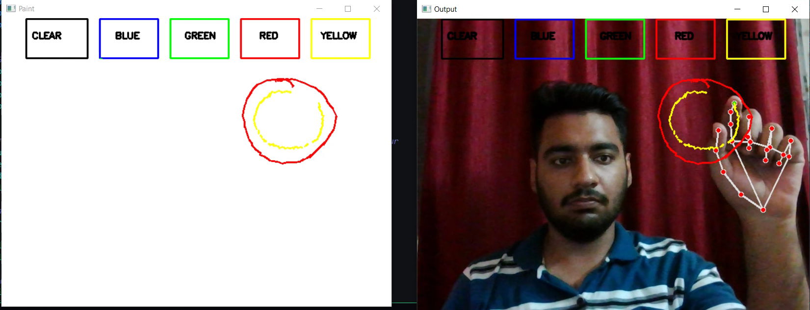

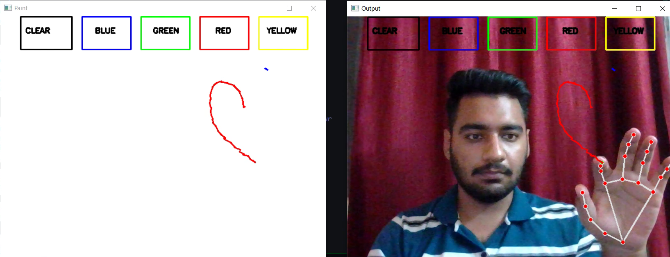

***TEAM MEMBERS*:-**

* PULKIT ARORA -102103267
* ISHAAN GABA -102103281
* SEHAJBIR SINGH BAINS-102103290
* GEET INDER SINGH SODHI-102103292